Practical 5: Doubly Linked List and Circular Linked List Operations
Practical Aim
To implement core doubly linked list and circular linked list operations and understand how bidirectional and circular linking change the way nodes are inserted, deleted, and traversed.
Problem 1
A music player maintains a playlist where songs can be added to the beginning, added to the end, or inserted right after a specific song that is currently playing. When a song is removed, only the first song in the playlist is dropped. At any point the player can count how many songs are in the playlist and display them from first to last. Given a sequence of such operations, implement all of them on a doubly linked playlist and print the result after each operation.
Describe how your insertion after a given song works. What extra step does a doubly linked list require here that a singly linked list did not? What happens if the given song is not found in the playlist?
SOLUTION:
https://github.com/prathameshpandir-dev/DSA-Batch-B-SHP/tree/main/practical-5
OUTPUT:



PROBLEM FACED:
The main difficulty was updating both the next and previous links correctly while inserting a song after a given song. The target song also has to be checked before insertion.
CONCLUSION:
The doubly linked playlist operations were successfully implemented. Songs can be added at the front and end, inserted after a selected song, removed from the front, counted, and displayed in order.
Problem 2
A group of students are sitting in a circle playing a passing game. A token starts at the first student and is passed around the circle one student at a time. Students can join the circle at any position and leave at any time, and the circle must remain unbroken. Given a sequence of join, leave, and display operations, implement them on both a singly circular and a doubly circular linked list and print the current circle after each operation.
Describe how your solution ensures the circle stays unbroken after a student leaves. What is the one case where breaking the circle is most likely to happen as a bug, and how did you handle it?
SOLUTION:
https://github.com/prathameshpandir-dev/DSA-Batch-B-SHP/tree/main/practical-5
OUTPUT:
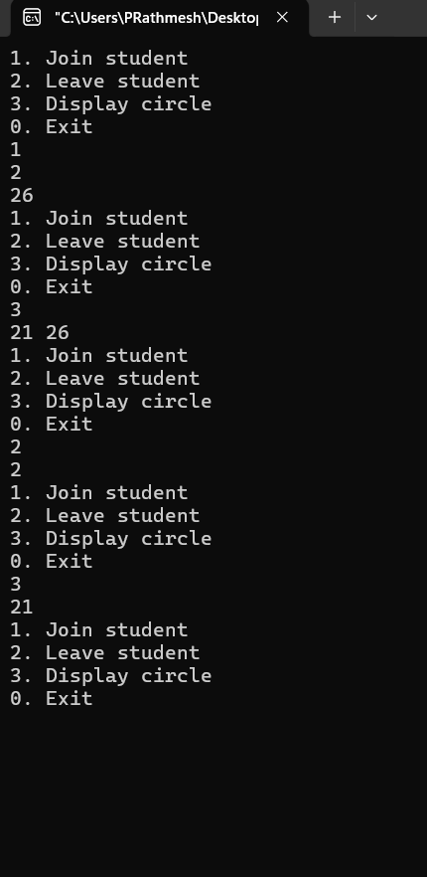

PROBLEM FACED:
The main difficulty was maintaining the circular connection when a student is inserted or removed. The single-node case needs special handling because the first and last links point to the same node.
CONCLUSION:
The circular list operations were successfully implemented. The links are updated after insertion and deletion so that the circle remains connected and traversal stops after one complete round.
Key questions
1. Problem 1
Answer: When the first node is deleted, the second node becomes the new head. In a doubly linked list its previous pointer must also be changed to null. If this is forgotten, the backward link still points to the deleted node and the list becomes incorrect.
2. Problem 2
Answer: Traversal must stop when it reaches the starting node again. The last node must point back to the first node instead of null. If the last link is set to null, the circular connection is broken and the traversal will not represent a complete circle.
Overall Conclusion
The practical successfully demonstrated doubly linked and circular linked list operations. The main focus was on updating multiple links correctly and preserving circular connections during insertion, deletion, and traversal.

